* **Create a database called "contact" :**

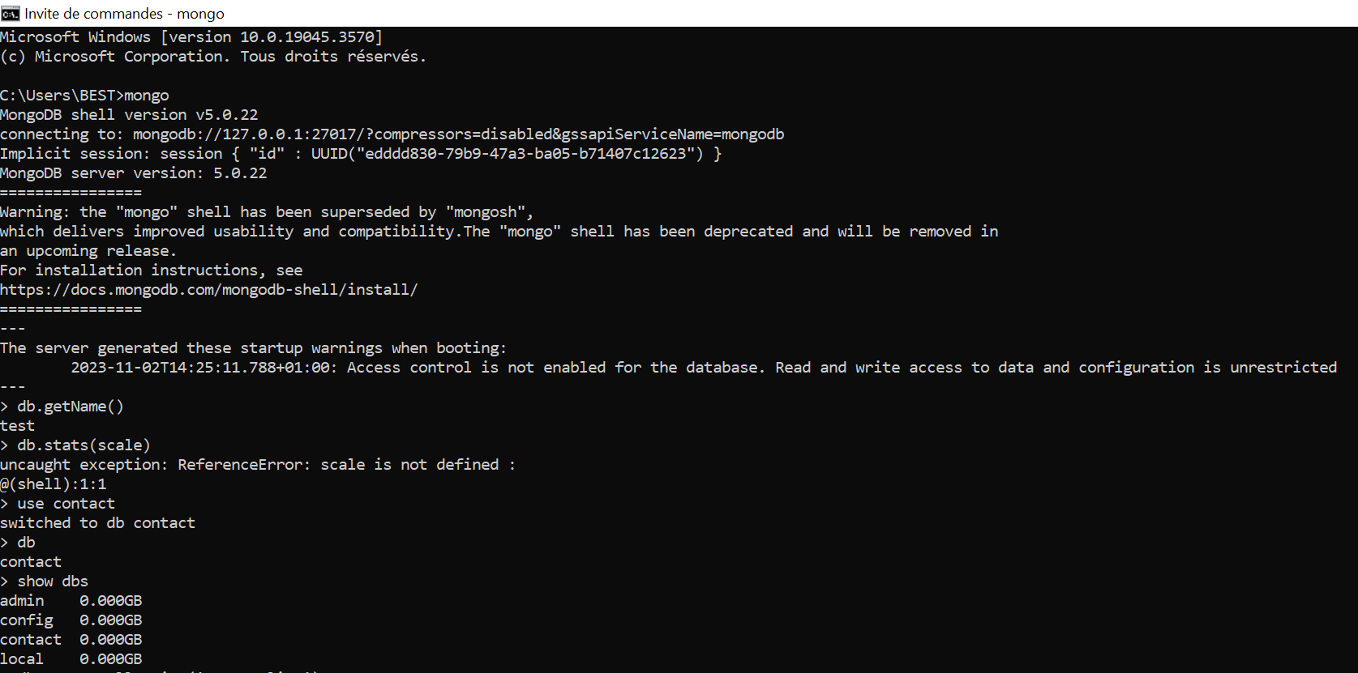

* **Create a collection called "contactlist" :**

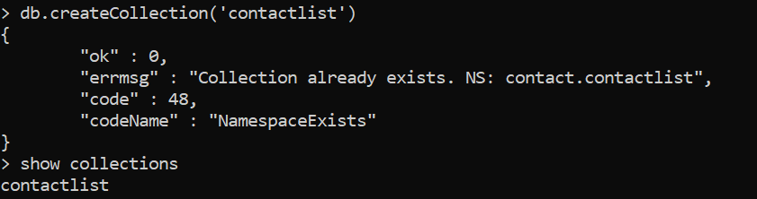

* **Insert these documents  in "contactlist" :**
  + *Last name: Ben Lahmer, First name: Fares, Email: fares@gmail.com, age:26*
  + *Last name: Kefi, First name: Seif, Email: kefi@gmail.com, age:15*
  + *Last name: Fatnassi, First name: Sarra, Email: sarra.f@gmail.com, age:40*
  + *Last name: Ben Yahia, First name: Rym, age:4*
  + *Last name: Cherif, First name: Sami, age:3*
  + 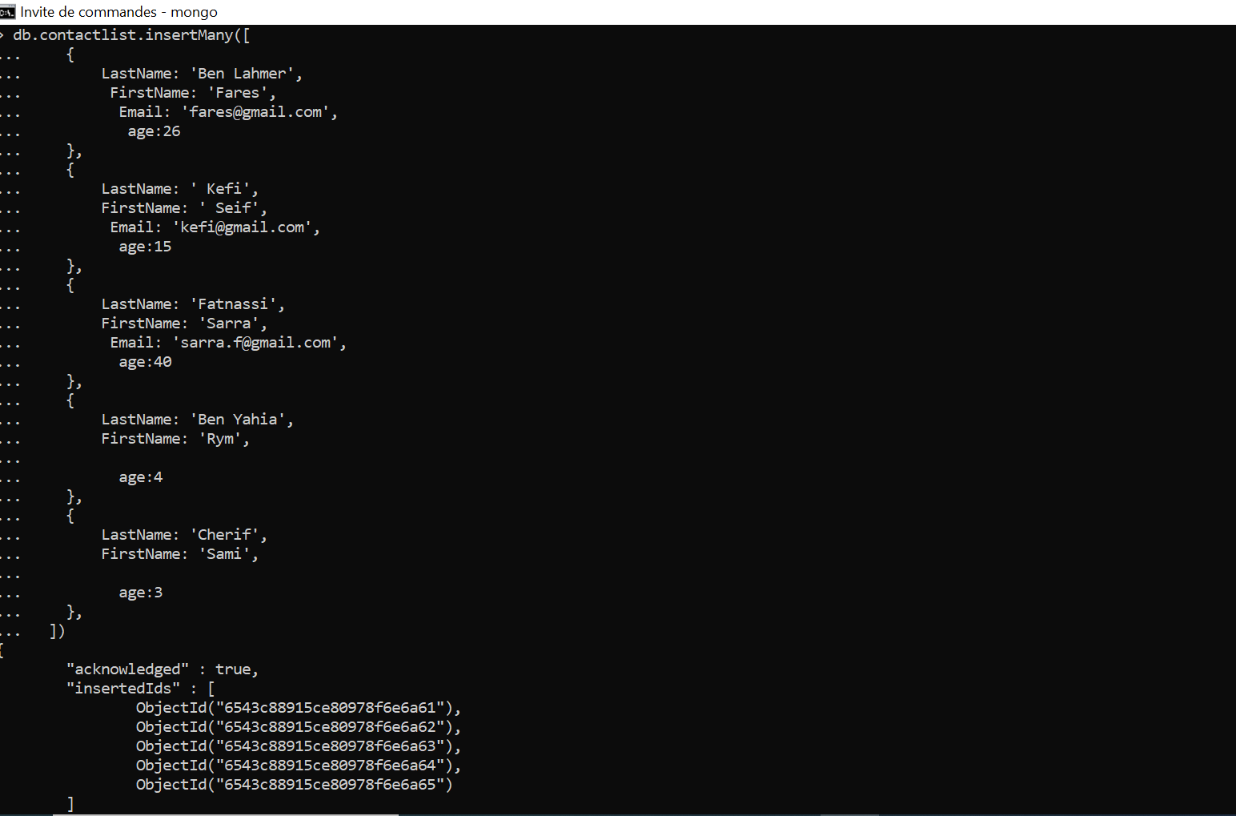

***Display all of the contacts list :***

* **Display all the information about only one person using his ID.**

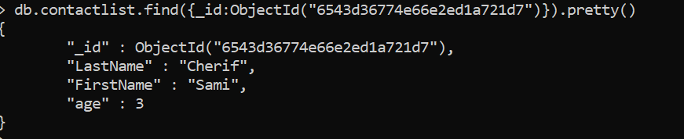

* **Display all the contacts with an age <18.**

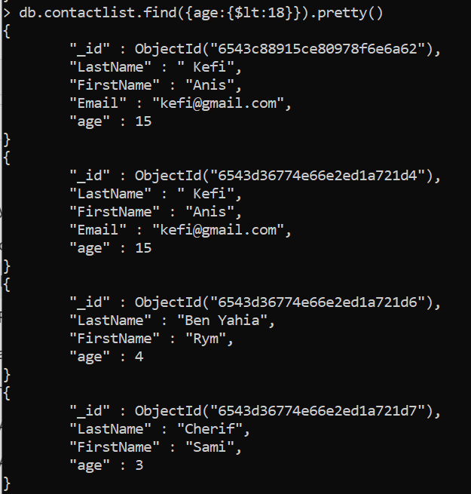

* **Display all the contacts with an age<18 and name containing "ah".**

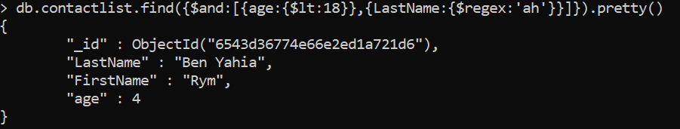

* **Change the contact's first name from"Kefi Seif" to "Kefi Anis".**

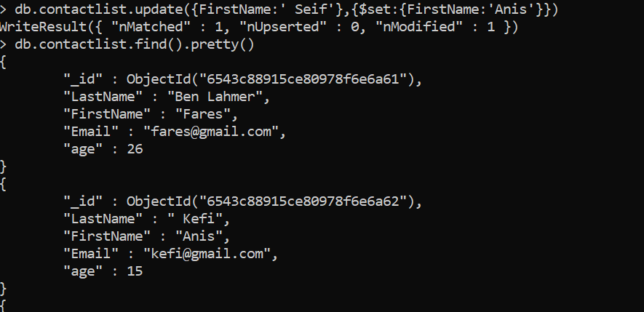

* **Delete the contacts that are aged under >5.**
* **Display all of the contacts list.**

